Name:
Basic Atom Practice
Biology 16-17
- Parts of an atom
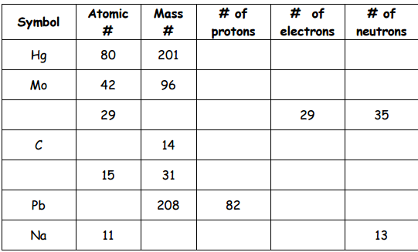
- Ionic Bonding
Element | Electrons | Valence Electrons
Potassium (K)
Iodine (I)
Calcium (Ca)
Sulfur (S)

To show the ionic bond:
- Draw the symbols for the ions
- Show me the charge on the ion including the number of electrons gained/lost.
- Put the elements together in the correct proportions to make a new compound.
- Potassium (K) + Iodine (I)

- Calcium (Ca) + Sulfur (S)

- Covalent Bonding
Element | Electrons | Valence Electrons
Oxygen (O)
Hydrogen (H)
Fluorine (F)
Bromine (Br)

To show the covalent bond:
- Draw the symbol for the elements
- Draw dots to represent the number of valence shell electrons around the symbol
- Show sharing by circling and connecting lonely electrons from the different elements.
- Share electrons until each element is happy.
- Put the elements together in the correct proportions to make a new compound.

- Hydrogen and Bromine

- Oxygen and Fluorine

You Decide: Ionic or Covalent
If Ionic:
- Draw the symbols for the ions
- Show me the charge on the ion including the number of electrons gained/lost.
- Put the elements together in the correct proportions to make a new compound.
If Covalent:
- Draw the symbol for the elements
- Draw dots to represent the number of valence shell electrons around the symbol
- Show sharing by circling and connecting lonely electrons from the different elements.
- Share electrons until each element is happy.
- Put the elements together in the correct proportions to make a new compound.
Barium (Ba) and Chlorine (Cl) Hydrogen (H) and Carbon (C)

Fluorine (F) and Fluorine (F) Rubidium (Rb) and Oxygen (O)

