Organic Chemistry: Naming Alkanes
Review Guide Chapter 2 Quiz (19 Questions)
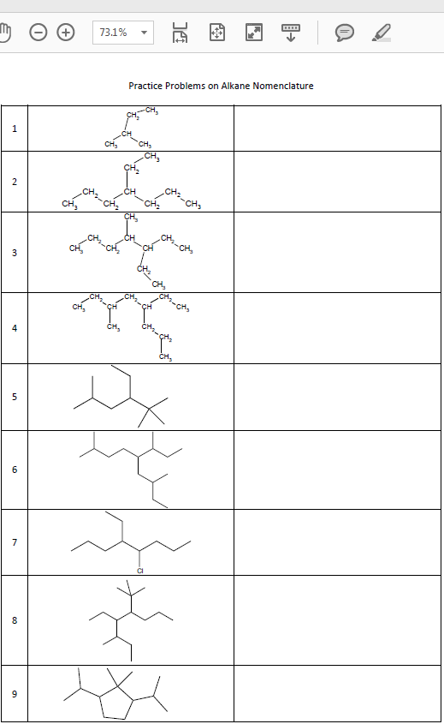
Draw the following molecules in each of the five formula types.
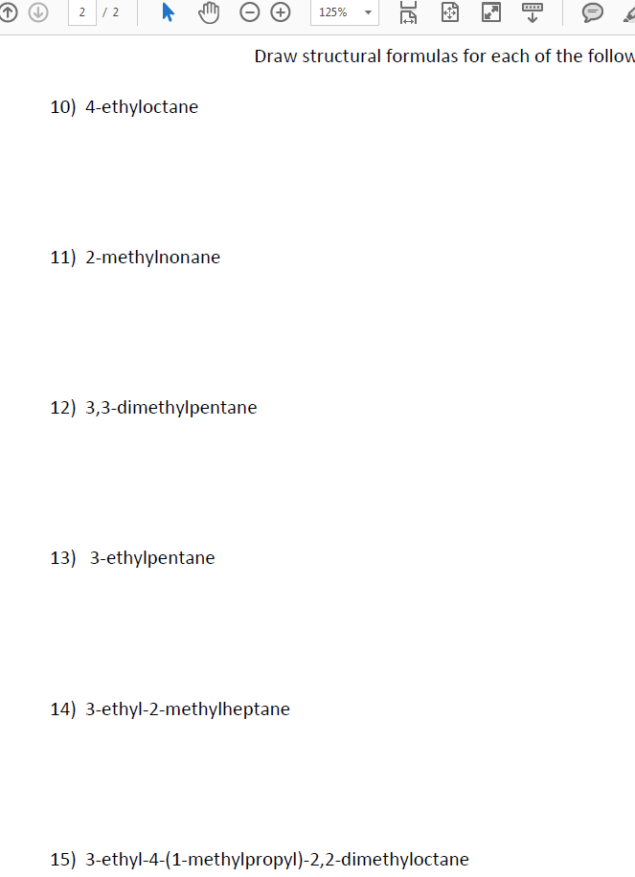
iodooctane

Cis/Trans Naming Practice
Molecule | Name
 | Cis-2-betene
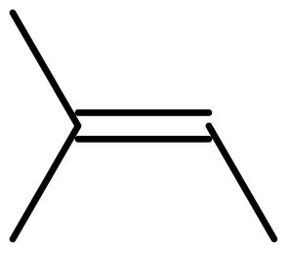

 | Trans-1,2-dibromocyclopentane
 | Cis-1,4-dimethylcyclohexane
Question Count: 14 Naming Questions, 3 Complex Branch, 3 Cis/Trans

