|  |
| --- |
| C:\Users\Sue\Desktop\Contour_Maps001.bmp |
| C:\Users\Sue\Desktop\Contour_Maps001.bmp |
| C:\Users\Sue\Desktop\Contour_Maps001.bmp |
| C:\Users\Sue\Desktop\Contour_Maps001.bmp |

A.

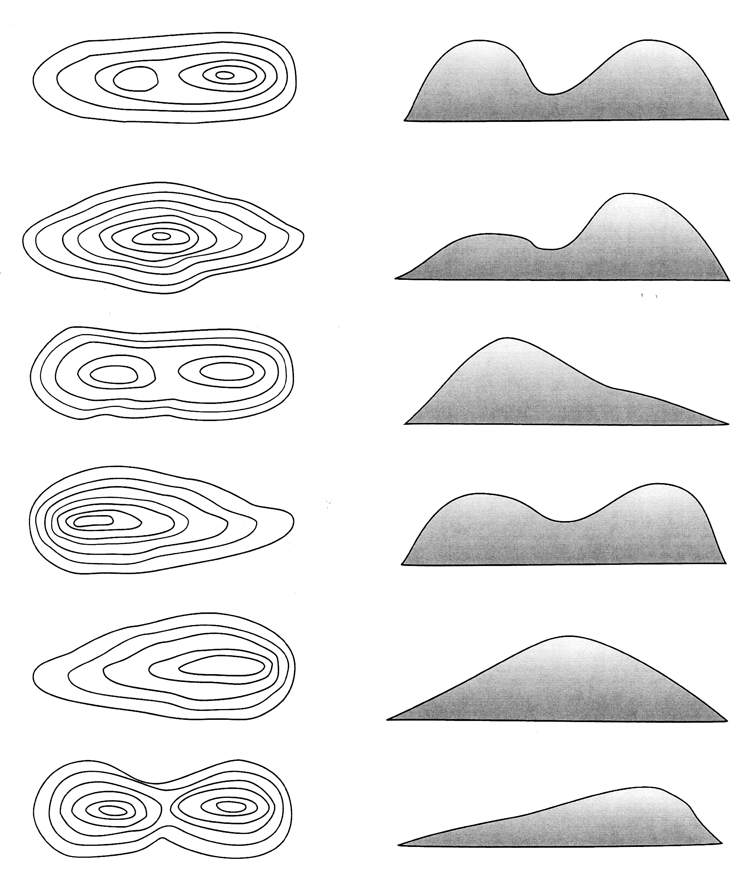

|  |
| --- |
| C:\Users\Sue\Desktop\Contour_Maps001.bmp |
| C:\Users\Sue\Desktop\Contour_Maps001.bmp |
| C:\Users\Sue\Desktop\Contour_Maps001.bmp |
| C:\Users\Sue\Desktop\Contour_Maps001.bmp |



|  |
| --- |
| C:\Users\Sue\Desktop\Contour_Maps001.bmp |
| C:\Users\Sue\Desktop\Contour_Maps001.bmp |
| C:\Users\Sue\Desktop\Contour_Maps001.bmp |
| C:\Users\Sue\Desktop\Contour_Maps001.bmp |



|  |
| --- |
| C:\Users\Sue\Desktop\Contour_Maps001.bmp |
| C:\Users\Sue\Desktop\Contour_Maps001.bmp |
| C:\Users\Sue\Desktop\Contour_Maps001.bmp |
| C:\Users\Sue\Desktop\Contour_Maps001.bmp |



|  |
| --- |
| C:\Users\Sue\Desktop\Contour_Maps001.bmp |
| C:\Users\Sue\Desktop\Contour_Maps001.bmp |
| C:\Users\Sue\Desktop\Contour_Maps001.bmp |
| C:\Users\Sue\Desktop\Contour_Maps001.bmp |



|  |
| --- |
| C:\Users\Sue\Desktop\Contour_Maps001.bmp |
| C:\Users\Sue\Desktop\Contour_Maps001.bmp |
| C:\Users\Sue\Desktop\Contour_Maps001.bmp |
| C:\Users\Sue\Desktop\Contour_Maps001.bmp |

