Observation vs. Inference
Physical Science

Observation:

- Using one of the _____________________ to make understand the world around you.

    - Sight, touch, hearing, smell, ________________ (NOT in science class!)

    - ____________!!! Example: There is one TV in the room.

- Types of observations:

  - Qualitative: Description based on observations or “relative” comparison; _____________

_____________________________________________

  - Quantitative: Measured & numerical; _______________________________

- Recorded as ____________________in an experiment. Data = __________________________

Inference

  - Logical interpretation/explanation.

  - Using reasoning to make sense of what you are observing

  - BASED on observations

  - Example: You entered the classroom and a new adult was by my desk. You might infer that I ________________or that the new adult is a _____________________________.

  - Clues You Are Making an Inference; I think.., Like…, Because…

  - Used in writing the ______________________of a lab report.

Practice: Determine whether the statements below are observations or inferences. Write the letter “O” next to the statement if it is an observation and an “I” next to the statement if it is an inference.

1. The temperature at noon was 78 degrees.
2. It is a very hot day.
3. The price of gasoline is rising.
4. Bill’s car is very fast.
5. The test was very easy.
6. The candle weighed 71 grams.
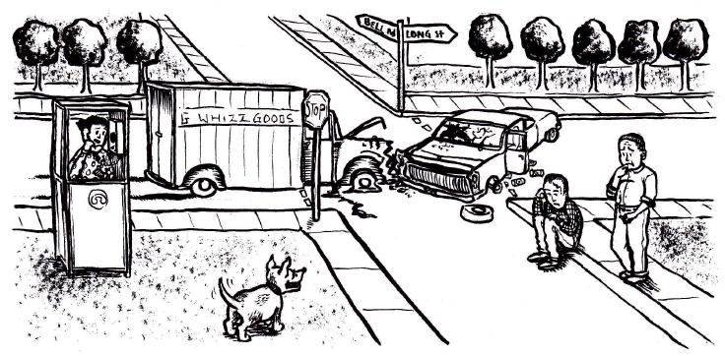

Using the picture above write 2 observations (1 Qualitative and 1 Quantitative) and 2 Inferences about the picture above.
Observations Inferences
Qualitative 1).
1). 2).
Quantitative
1).

