Name (First & Last)______________________ Period____

Chapter 2: Mapping Our World Note Outline
Objectives
- Compare and contrast latitude and longitude. This means that:
  - I can describe the differences between latitude and longitude according to
    - Their point of references (name of their respective 0º degree line)
    - The direction they run around the earth
    - Relationship between lines: parallel, converging,…
    - Whether they are labeled N vs. S, or E vs. W
  - I can compare their similarities, including how each degree is broken down into smaller units
  - I know the latitude or longitude of key areas of the earth including the Equator, North Pole, South Pole, Prime Meridian, International Date Line, Tropic of Cancer (23.5N), Tropic of Capricorn (23.5S).
- If given the latitudes and longitudes I can:
  - Determine which of 2 cities is farthest from the Equator, Prime Meridian or International Date Line
  - Calculate the distance further north or south (in km) one city is compared to another. Because 1º latitude = ________km.
  - Use a map to pinpoint and identify the location.
- Analyze & create topographic maps. This means that I can:
  - Describe the use of and identify the following on a topographical map: contour line, contour interval, index contour, hachure, depression contour.
  - Determine whether an area is flat vs. hilly using a contour map, based on the spacing between contour lines..
  - Create 3D versions of real topographic map, and vice versa create a 2D topographic map from 3D terrain.
  - Calculate the gradient between 2 given points.
  - Calculate the contour interval of a given map.
- Define watershed and describe how to tell where the boundaries are. Understand how runoff affects our water quality.

Latitude: Distance in degrees _________________ of the _________________ (0 – 90º N or S)

- Latitude lines are like

  - ____________________ - like a belt running ____________the earth. RUNNING/DRAWN East to West

  - “Ladder” rungs on the Earth & are LABELLED _______________ of the equator

- _______________________

- Equator = ______________

- Poles = _________________

- 23.5N = ___________________________________

- 23.5S = ___________________________________

- 1º latitude is about 111 km (68 miles) on Earth’s surface

- Each degree divided into 60 ______________(60’)

- Each minute is divided into ______________ (“)
Longitude: Distance in degrees ________________ of the _____________ ____________

- Longitude lines are like _________________ & RUNNING/DRAWN North to South

- Prime meridian = _____ longitude (goes through Greenwich, England)

- LABELLED ___________________

- International Date Line is _________

  - On opposite side of world from the prime meridian

  - Where all _______________________ meet: _________________ a day if cross

- Semi-circles from pole to pole

- _______ parallel: ____________ at poles, ________________at equator

- Does 111km separate each degree longitude? Explain.

Mapping Coordinate Example
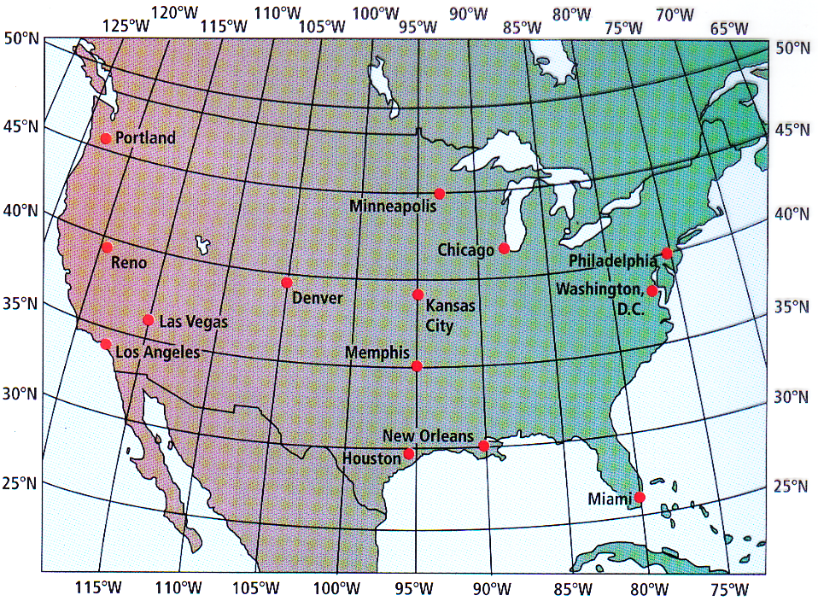
- New Orleans: 29º 57’ N, 90º 04’ W

- Always list ____________ 1st

Practice Problems Using the map at right:
- Coordinates of Washington D.C?

- What city is at 30N 90W?

- Which is further from Greenwich England, in degrees, Philadelphia or Denver? EXPLAIN QUANTITATIVELY.

- Which is closer in degrees to the International Dateline? Minneapolis or Portland? Explain QUANTITATIVELY.

- Memphis:
- How many km is Memphis from the Equator? SHOW YOUR WORK.

- How many km is Memphis from the North Pole? SHOW YOUR WORK.

- How many km is New Memphis from the South Pole? SHOW YOUR WORK

- How many km south of Minneapolis is Memphis? SHOW YOUR WORK

Section 2.2 Types of Maps

Topographic Maps

- Detailed maps showing Earth’s ______________ features: hills, valleys, rivers, forests, bridges

- Contour lines connect points of ____________ elevation

  - Contour lines never cross. Why?

  - Contour _____________: __________________ in elevation between 2 contour lines

  - ___________ contours: Lines marked with _____________ representing their elevation

  - Depression Contour Lines: Hachures, ____________________ at right angles to the

contour lines, point toward _____________ elevations and indicate depressions

    - Used for volcanic craters, etc.

- Gradient: Calculation showing the ___________________ of a slope

  - _______________________ = Gradient

  - Example: If you climbed a mountain trail that was 2 miles long from the base camp at an elevation of 7500 ft to its peak at 11500ft, what was the trail’s gradient?

Various Land Form Examples Match the Side View to the Map
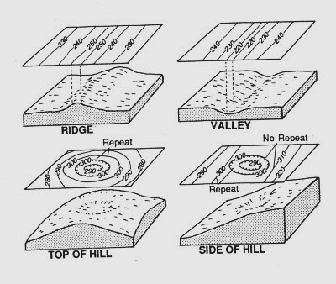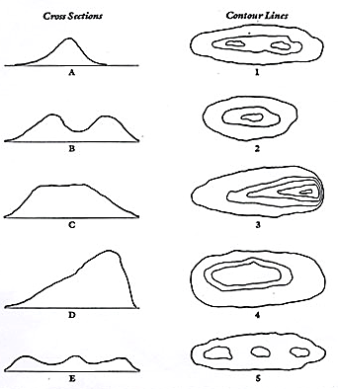

Side View D above has gradients of 70m/km and 20m/km.
- Which side has the gradient of 70m/km?
- How did you decide?
- What is the gradient if it is FLAT?
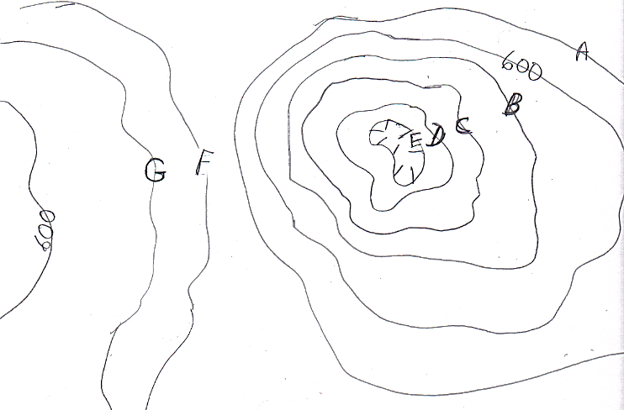
Example Map
  - If the contour interval is 20 feet, what is the elevation of lines

A ___________, B_________,

C___________, D_________,

E___________, F_________,

G___________

  - What side of the hill with the depression at the top is steeper?

  - What is the elevation of the index contour?

Gradient Problem #1:
- The distance from Point G to Point H on a map is 9.6cm. The scale on the map says that 1 mile = 3 cm. Write an equation using a conversion factor to determine how many miles apart the two points are. Show your work. Include units on your conversion factor and your answer.

- The elevation of Point G is 625 feet, while the elevation of Point H is 433 feet. Combining this information with the distance calculated above, determine the gradient between Point G & Point H. Show your work. Label your work and your answer with units.

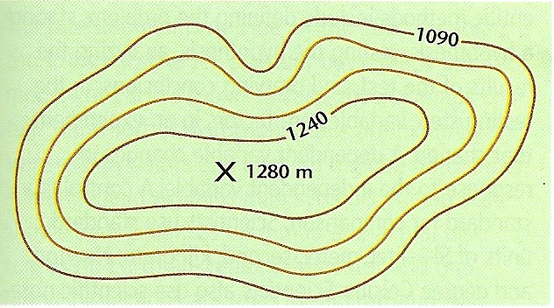
Gradient Problem #2:
Calculate the gradient from Point C to Point D through the following steps. Show your work.

- What is the contour interval?
*D
*C
- Determine the elevation of the line Point D is on.

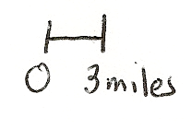

- Determine the distance in miles.

- Write an equation to determine the gradient between Point C & Point D.)

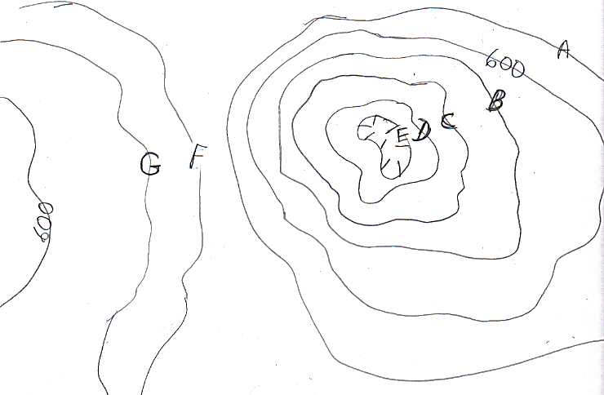
Gradient Problem # 3

Contour interval = 20 ft
Calculate the gradient from Point F to Point H. Show your work. Label the units in both the work and the answer.

Crumpled Paper Watershed Lab- Formative Assessment

- Choose the best description for the watershed of a stream:
  - The water of a stream and all the tributaries that feed into it, including wetlands
  - All the land that slopes toward the stream and drains rain and melting snow into the stream
  - A large wet area of land that completely surrounds the stream.

- You are hiking along a trail in a hilly countryside. You know that you have reached the watershed of a different stream because:
  - The ground changes from soggy soil to dry forest
  - You can see another stream
  - You are standing on a high spot and the land starts to slope downward again.

What is a Watershed?

- Watershed = All the ____________________________ into a stream, river, lake or ocean.

- Runoff = Extra __________________ or snowmelt that _________________________ by soil and vegetation and “runs off” the land into a body of water.

- The boundary of a watershed is the __________________________________ surrounding it, like the edge of a bowl.

  - _________________________________________ = Another term for watershed

Human Effects on Watershed

Runoff carries whatever is on the land, causing ____________________ of bodies of water. Examples:

- _____________________ – from farms & human ___________________

- Chemicals: ___________________________ etc. from farms and city

- _________________________________ – from fields & city construction sites

- _______________________ – from cars & factories

THINK ABOUT THIS the next time you swim or boat in Duck Creek or the Mississippi!!

DIRECTIONS BELOW ARE FOR THE MAP & GRAPH on the next page.

PRACTICE: YOU Draw the Side View/Silhouette

On the map on the next page of Cottonwood Colorado:

- Put an “S” on the location that is the “Steepest” in the diagram above. Mark an “F” on a large area that is relatively “Flat”.

- On the grid above, construct a topographic profile representing the cross-section between Point A and Point B, following the directions below:

  - Tear off the last page of this outline which has an extra copy of the map.

  - Above the line marked AB, label each line with its elevation. This will make it easier to know where to graph the points.

  - Plot the elevation of the land along line AB by marking with a dot, the elevation of EACH point where a contour line is crossed by line AB.

  - Connect the dots with a smooth, curved line to complete the topographic profile (AKA silhouette or cross-section).

Practice 2D to 3-D Silhouette/Side View

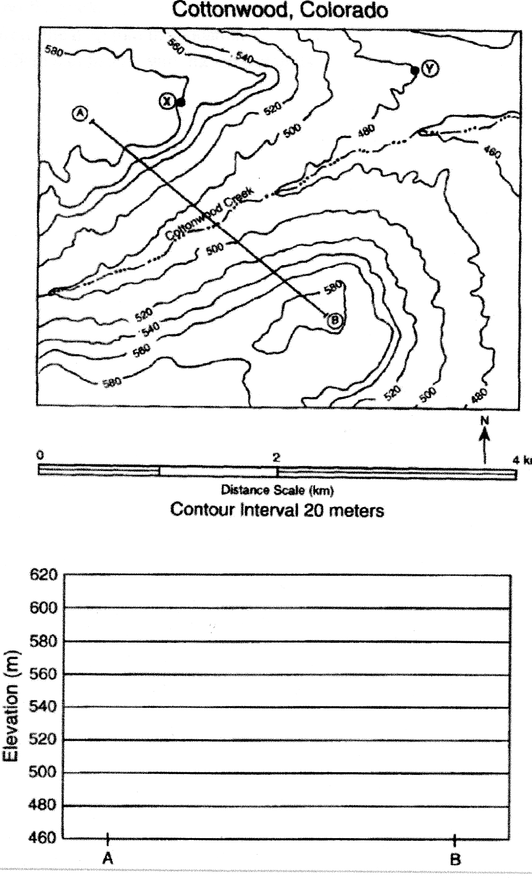

LEAVE THIS PAGE BLANK

So the next page can be torn off &

used separately

