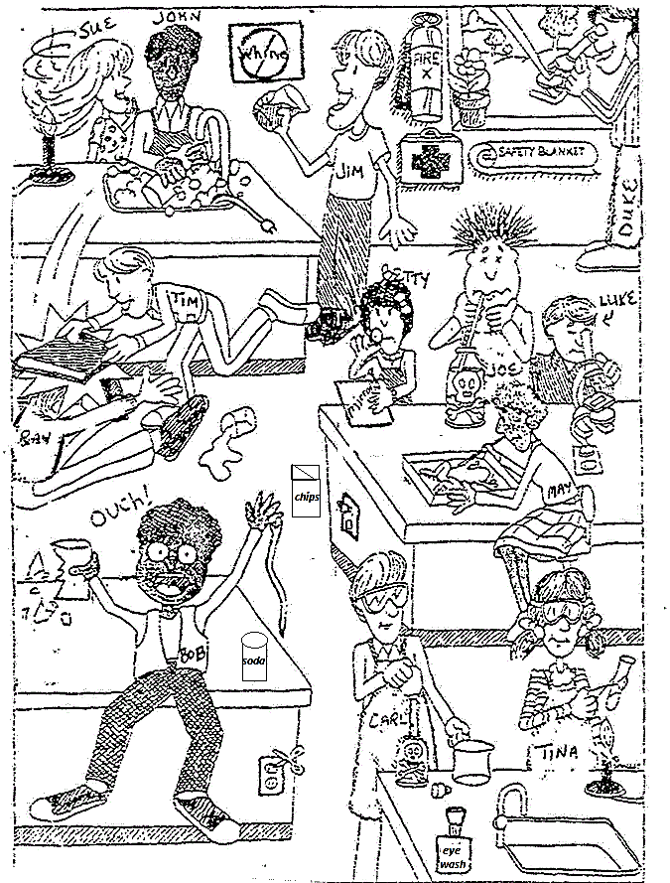
Cartoon Questions
- List 3 unsafe activities shown in the illustration and explain why each is unsafe.

- List 3 correct lab procedures depicted in the illustration.

- What should Bob do after the accident?
4. What should Sue have done to avoid an accident?
5. Compare Luke and Duke's lab techniques. Who is following the rules?
6. What are three things shown in the lab that should not be there?

7. Compare Joe and Carl's lab techniques. Who is doing it the correct way?
8. What will happen to Ray and Tim when the teacher catches them?
9. List three items in the illustration that are there for the safety of the students in the lab.

10. What is Betty doing wrong?

