**Topography Formative Assessment**

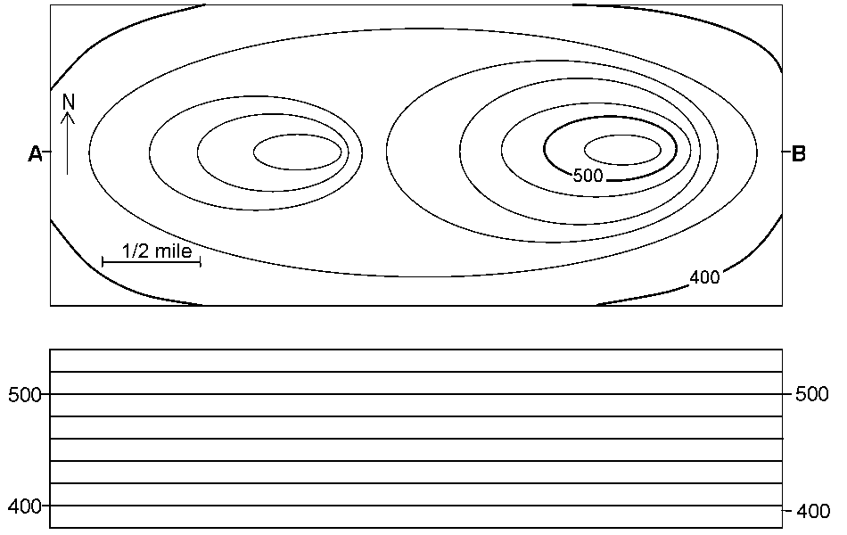

C

D

1. What are the elevations for the two index contours in this diagram?
2. What is the contour interval in this diagram? Make sure to show your work!
3. Mark a location on the map with ‘S’ that you would expect to be steep.
4. Mark a location on the map with ‘F’ that you would expect to be flat.
5. Write the equation for gradient (in words!).
6. What is the elevation of Point C? Point D?
7. What is the distance between Points C & D?
8. Calculate the gradient between points C & D.
9. Using the diagram and graph below, draw the silhouette of line AB. In other words, what would the side view of this feature look like?



B

A