Name:
Chapter 8 & 9 Genetics & Biotechnology Review Questions
Types of Gene Transfer
- What is the difference between horizontal and vertical transfer of genes?

Vertical Transfer
- Through what process are genes vertically transferred in bacteria?

Horizontal Transfer
- Fill in tables below regarding forms of horizontal gene transfer.
Types of Horizontal Transfer | Definition (Description of process) | Examples/Uses | Limitations
Transformation

Conjugation

Transduction

Types of Horizontal Transfer | Diagram (Show how the process works/steps)  In each label: Vector , Source of transferred gene (human, plant, bacterial), and the resulting product (a protein for harvest or modified organism/plant).
Transformation
Conjugation

Transduction

- Fill in the table below regarding the terms related to genetic engineering of bacteria.
Term | Definition | Function in Genetic Engineering
DNA ligase

Restriction enzyme

Clone

Plasmid

Bacteriophage

Marker

Vector

Competency

Sticky ends

Blunt ends

- E. coli and Saccharomyces are both commonly engineered to make human proteins. What advantage does Saccharomyces sometimes have over the use of E.coli?

Lab #28 Conjugation:
- There were 2 resistant genes in the lab. Were both genes transferred to the other bacteria? Why or why not?

Lab #29 Transformation:
- Define and explain the relationship between genotype and phenotype in the “Glow in the Dark” lab.

- What components of the lab caused the E.coli to take up the plasmid?

- Why was the amp-r gene necessary in this lab? Explain.

The “paper” plasmid lab: Make sure you understand how to answer questions similar to the ones on this lab sheet. If you missed questions, ensure you know why and can fix them.

- How do you identify restriction enzyme sites on a given piece of DNA if given the enzyme recognition sequence?

- What is the natural function of restriction enzymes?

- In the following diagrams, you need to identify the following:
  - Vector
  - Source of transferred gene – human, plant, bacterial
  - Process involved: transformation, conjugation, transduction, reproduction
  - Resulting product - whether a protein for harvest or modified organism/plan

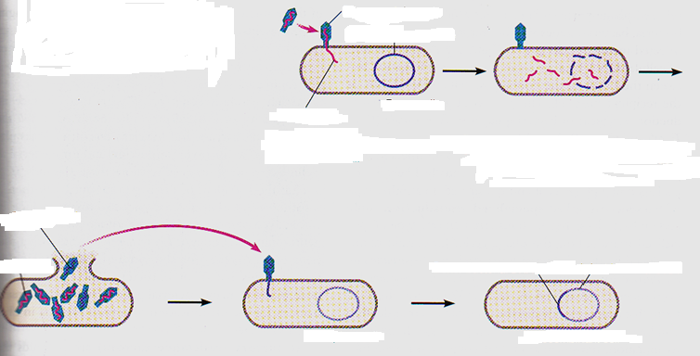

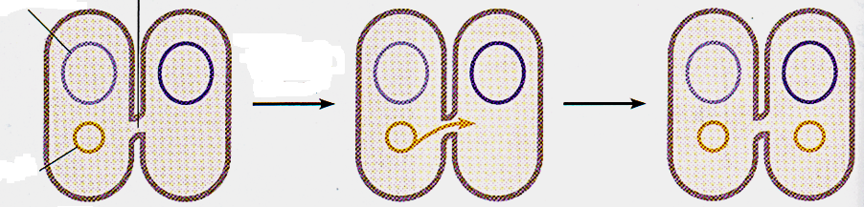

- In the following diagrams, you need to identify the following:
  - Vector
  - Source of transferred gene – human, plant, bacterial
  - Process involved: transformation, conjugation, transduction, reproduction
  - Resulting product - whether a protein for harvest or modified organism/plan

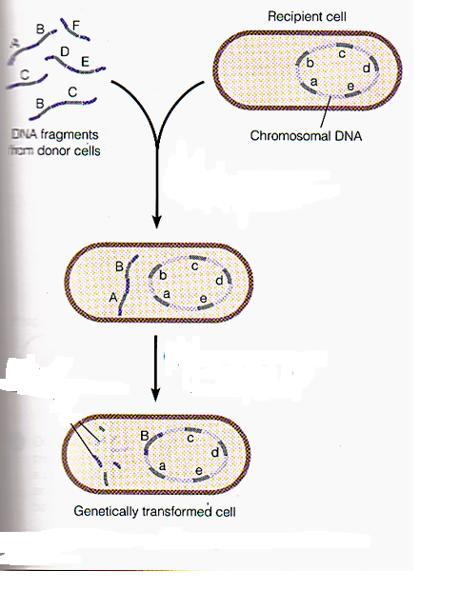
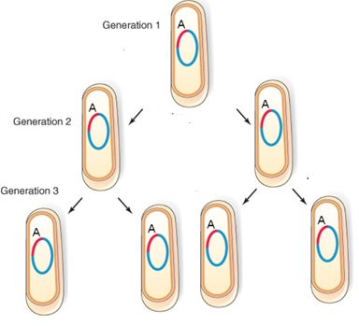

Plasmid Genes
- Fill out the table below regarding plasmids.

Type of Gene | Purpose of Gene | Example
Conjugative

Dissimilation

R-Factors

